Task 1:Create a dynamo db table with minimum two disaster recovery zones and verify

replication.

ss1:Disaster recovery regions with the table

Home region

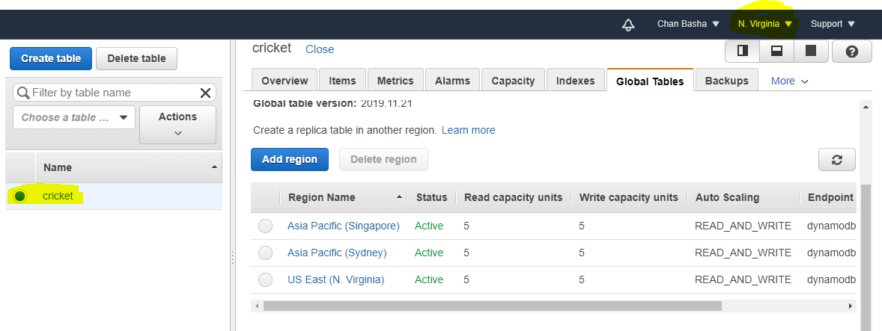

Disaster recovery region 1

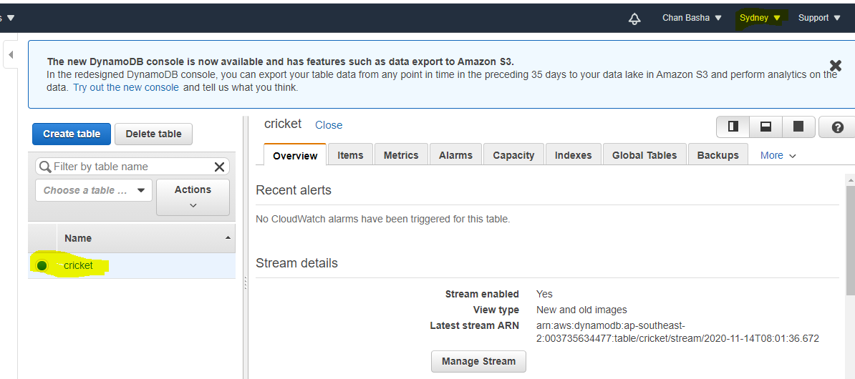

Disaster recovery region 2

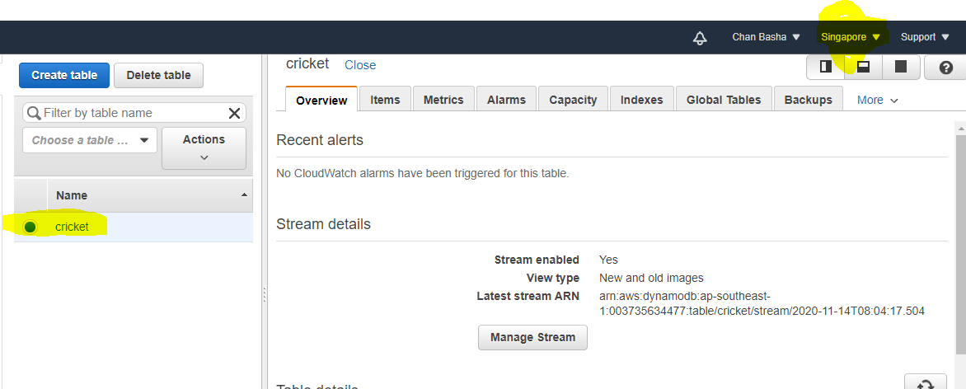

ss2: Home region with all items displayed

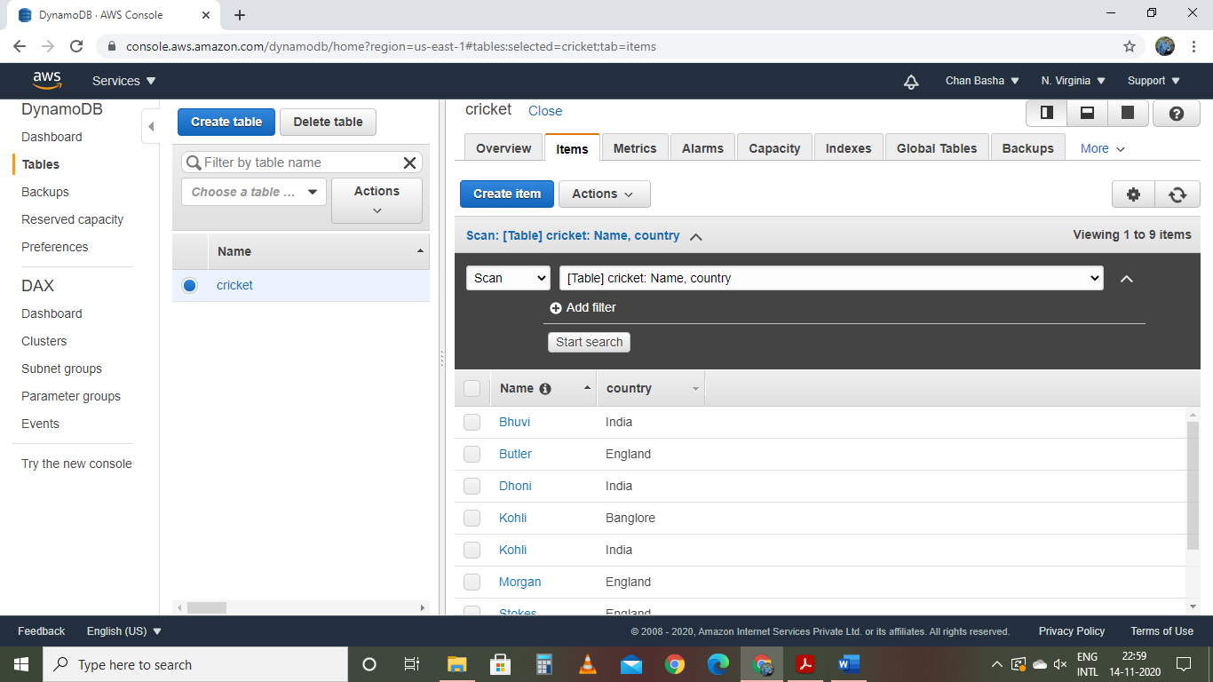

ss3: Use query to fetch few items

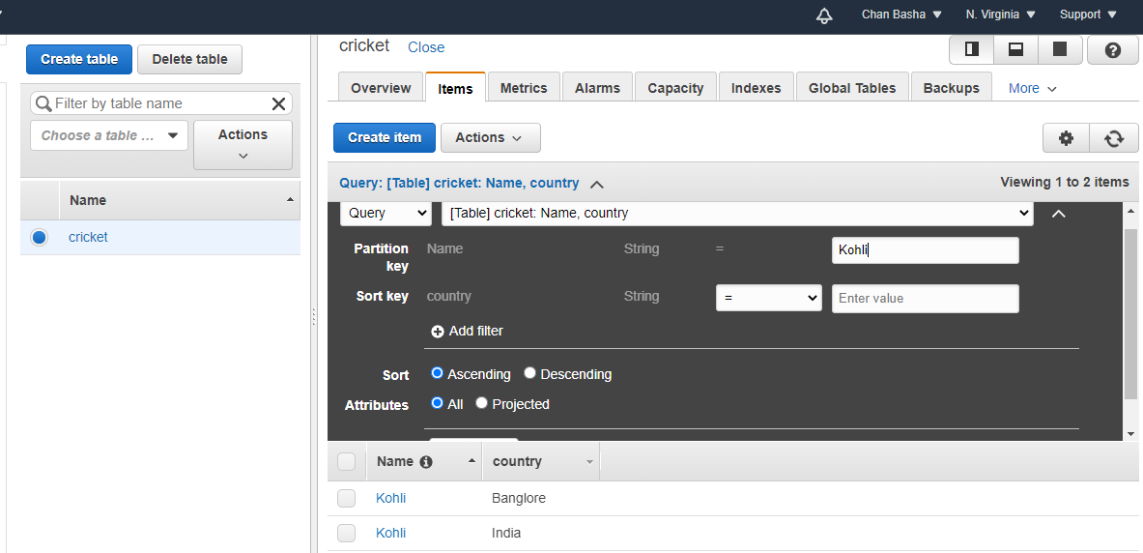

Task 2:Creating a dynamo DB table with global secondary indexes and fetching data using global secondary indexes.

ss1: Table with its items displayed

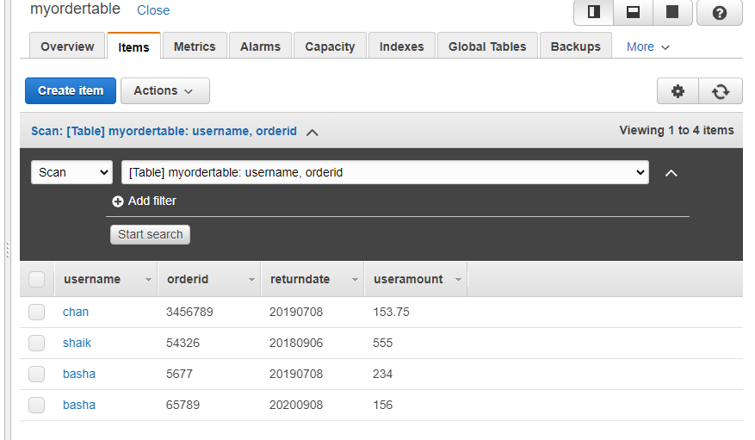

ss2:creating global secondary index

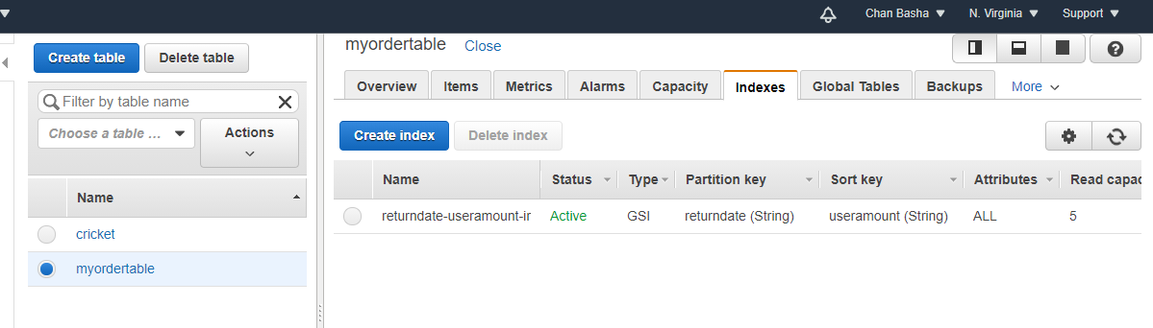

ss3: scan with global secondary index

using scan

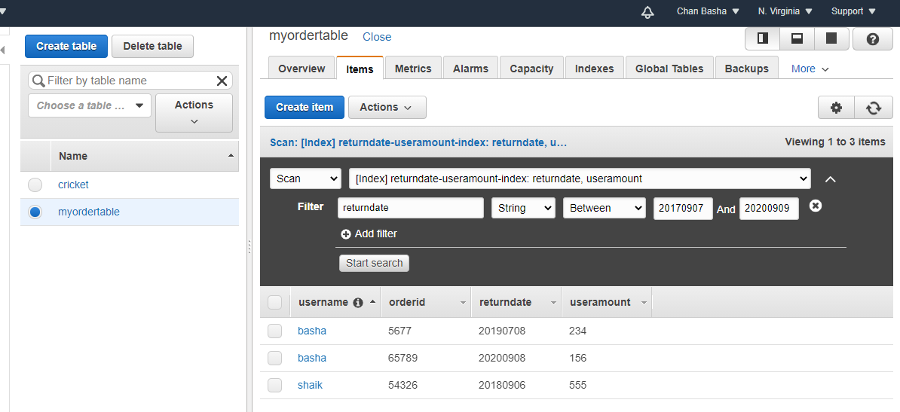

Using query

